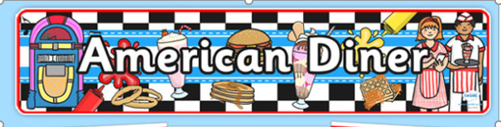
Richard Crosse American Diner
Thursday 03rd October 2019
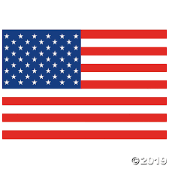
Mains

All American Hot Dog
OR
Classic American Burger
OR
Uncle Sam’s Jacket Potato
(with cheees, beans or tuna)
OR
Baltimore Baguette
(with ham, cheese or tuna)
Sides

Philadelphia Fries
Boston Baked Beans
Sasquatch Sweetcorn

Puddings
Pittsburgh Pancakes with syrup & ice cream
Fresno Fruit Platter

