Class 5: Autumn Term 1 2019-20
Welcome Back!
We would like to offer a warm welcome back to both yourself and your child. We hope you have had a lovely summer break and are well and truly rested. This term, your child can look forward to the many exciting activities we have planned.

Mr Davies and Miss Jarrett

Class 5 | Key Information
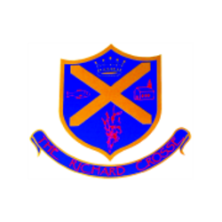  Uniform | Remember that a blazer is a compulsory part of the uniform and that your child should wear this at all times unless given permission otherwise. Please make sure all uniform is clearly labelled to avoid any loss. Bring a coat to school as well as your blazers.  For further information, please follow the link below.  https://www.richardcrosse.staffs.sch.uk/parents/uniform
Reading Diaries | Please ensure that your child’s reading diary is in school every day, as we aim to try and listen to them read, in school, at least once a week. The children are encouraged to read at least five times a week at home and will need their diary signing by an adult to let us know how they are getting on. The children are responsible for changing their own books, when necessary, but this will be checked on a regular basis. Please note that your child does not have to read a whole book a night, it is acceptable to read just a few pages, especially as the books get trickier. Every time you child reads, they will receive 1 dojo. If they read 5 times in a week, they will be entered into a competition – 5 times reader – with the possibility of winning a book of their choice.
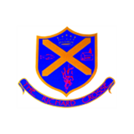  Spellings  Word tins | Your child will be expected to learn 5 spellings at home each week whilst being taught 5 in school. Please help your child to learn them. Spelling tests will take place on a Friday.  Your child will be tested on words in their word tins on a weekly basis. These words will include common exception words appropriate to your child’s level of learning.
PE Kit | Your child needs to bring a PE kit into school which is clearly labelled with their name. This must remain in school and will be returned at the end of each half term.  During the colder months, your child will need a tracksuit top and bottoms.  For further information, please follow the link below.  https://www.richardcrosse.staffs.sch.uk/parents/uniform
Homework | Homework will be sent home every Friday and will need to be handed in on a Wednesday. Each week, homework will alternate between English and Mathematics.  If your child is in Year 6, they may receive additional work to support their learning.

Our Curriculum this term...
English | ‘Thief’ by Malorie Blackman will form the basis of our reading and writing at the beginning of this term. This will not only be our focus within English lessons, but will link to our PSHE and Computing topics. Handwriting and presentation will be our priority as well as the application of correct spellings.  During our Guided Reading lessons, we will be reading more of ‘Thief’, using the text to answer comprehension questions including retrieval, inference and deduction.
Maths | Our focus this half term will be our Big Maths. Your child will undertake their tests every Friday and be supported through their needs during the week. Please support your child by keeping an eye out for their Big Maths sheets on a Friday and helping them with any incorrect answers.  Our focus will also be Place Value, all four operations and reasoning and problem solving. We will continue to learn time as this is a life skill that all our children should have. If you could support this area of maths at home, this would be really helpful!
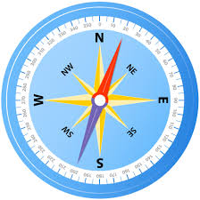  Geography | We have a really exciting Geography topic this term. Your child will be orienteering which will involve: designing our own maps; visiting other schools within the MAT (to try out their maps); and going on a trip Cannock Chase. Why not help your child become familiar with how a compass works and what an OS Map is.
Art | Your child will be exploring different techniques for drawing and painting landscapes this term. A number of opportunities to work outdoors and sketch the environment will be our top priority.
Computing | Computing will be taught through the English text ‘Thief’ this half term and will focus on E-Safety. Why not support your child by encouraging them to look at the following website and discuss what is on there.  https://www.thinkuknow.co.uk/8_10/
PE | This half term, PE will be taught on a Thursday and on a Friday. Our PE topics for this half term are Football and Leadership. In Leadership, we will be looking at Leadership and planning how we can support the younger members of our school family.
Religious Education/Science | Our RE and Science topics will encourage debate as we look at Creation and Evolution. Your child will be supported by Reverend Anne (Saint Mary’s Church reverend) and will be studying sections from the book of Genesis. In Science, your child will look at endangered animals, extinction and evolution.

