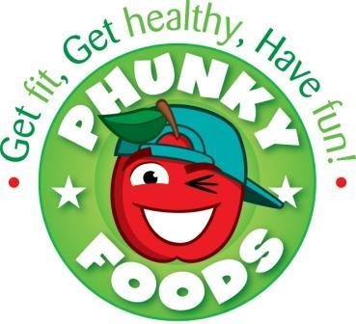

Dear Parents,

We are the Phunky Foods Ambassadors and this term we have been learning about healthy lunches. We would like to help your child/children have a healthy lunch and a healthy life. We have learned that a healthy lunch should include the following: Carbohydrates, Proteins, Vegetables, Fruit and dairy.

We have looked at the new school dinner menu, and found out that the school dinners include all these healthy food groups. Our school lunch desserts meet the school food standards as they are not made from chocolate or sweets. (We have learned that desserts like chocolate tray bake can be made with cocoa powder as this is much healthier than actual chocolate). Packed lunch desserts are the same, so homemade cakes can be made with cocoa powder rather than actual chocolate.

We have put together a checklist for healthy lunches which is attached to this letter. Next week we will be “Going On A Food Hunt!” in the dining hall to look at packed lunches. We will complete the checklist for any that we look at. Completed checklists will be anonymous and kept in school for us to look at and see where we can make improvements in school. So please put lots of great ingredients in for us to spot!

We have attached our own packed lunch picture guide with some more ideas.

P.S. We are a nut-free school, so no nut products please.

Thankyou

Ginny, Anya, Henry and Luca
The Yr5 Phunky Ambassadors

