Class 5: Spring Term 2020

Welcome Back!
Welcome back Class 5! Everyone at Richard Crosse wishes you a very happy and prosperous New Year! We hope you have had a lovely Christmas break and are well and truly rested. This term, you can look forward to many exciting activities and experiences, to enhance your learning and love of school.

Class 2 | Key Information
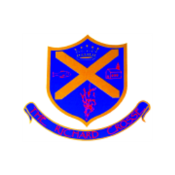  Uniform | Remember that a blazer is a compulsory part of the uniform and that your child should wear this at all times unless given permission otherwise. Please make sure all uniform is clearly labelled to avoid any loss. During this cold weather, please ensure your child has both their coat and blazer in school. For further information, please follow the link below.  https://www.richardcrosse.staffs.sch.uk/parents/uniform
Reading Diaries | Please ensure that your child’s reading diary is in school every day, as we aim to try and listen to them read, in school, at least once a week. The children are encouraged to read at least five times a week at home and will need their diary signing by an adult to let us know how they are getting on. The children are responsible for changing their own books, when necessary, but this will be checked on a regular basis. Please note that your child does not have to read a whole book a night. It is acceptable to read just a few pages, especially as the books get trickier. If they read 5 times in a week, they will be entered into a competition – 5 times reader – with the possibility of winning a book of their choice.
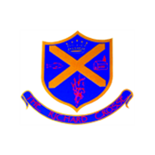  Spellings  Word tins | Your child will be expected to learn 5 spellings at home each week whilst being taught 5 in school. Please help your child to learn them. Spelling tests will take place on a Friday.  Your child will be tested on words in their word tins on a weekly basis. These words will include common exception words appropriate to your child’s level of learning.
PE Kit | Your child’s PE kit will need to be in school every day, as we may need to change days at the last minute due to weather etc. Please ensure that all items are clearly labelled with their name. We will send kits home at the end of each half term so that they can be washed.  During the colder months, your child will need a tracksuit top and bottoms.  For further information, please follow the link below.  https://www.richardcrosse.staffs.sch.uk/parents/uniform
Homework | Homework will be sent home every Friday and will need to be handed in on a Wednesday. Each week, homework will alternate between English and Mathematics. If your child is in Year 6, they may receive additional work to support their learning.

Our Curriculum this term...
English | This term, we will be reading the book ‘Animalium’, which focuses on different species of animals and their unique habitats. We will be attempting to write in the same style as the authors, using scientific vocabulary to convey information. By the end of the topic, we will have delved deep into the science of animals and habitats.
Maths  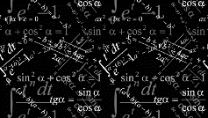 | We will continue to complete our Big Maths tests. We undertake our tests every Friday and our supported through our own needs during the week. Please support your child by keeping an eye out for their Big Maths sheets on a Friday and helping them with any incorrect answers.  Our focus for this half term will be fractions, decimals, percentages and algebra. If you could support your children in these areas it would be appreciated.
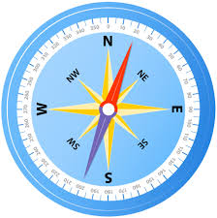  Geography | Our topic for this term in Geography is Habitats and Climates. We will be researching different climates around the world and will investigates how these create specialist habitats. We will examine many different habitats including: rainforest, deserts, forests and oceans; we will also explore the unique wildlife that lives in each of these areas.
D&T | We are extremely excited about our DT topic this term as we begin with RCrosse Racing. This term, we will begin to design and build our 3 Greenpower electric cars. All the children in year 6 will have the opportunity to construct the vehicles using a variety of tools. The year 5 children will be in charge of designing the body work and the aesthetics of the cars.
Computing | We will be continuing with computer Science this term but will be exploring this in more detail. The children will use their knowledge of algorithms to allow them to program simple and complex instructions using a variety of platforms.
PE | This term, PE will be taught on a Thursday and a Friday. Our PE topics will be focusing upon Dance and fitness. These sessions will be taught by Mr Challinor and Mr Davies.
Religious Education | We will be investigating what the religion of Islam is and what Muslims believe. We will discover what it is like to be a Muslim living in Britain and how their lives may differ from our own.
Science  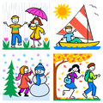 | In science this term, we will be studying living things. This will involve us researching various habitats around the world and discovering what creatures live there. We will also focus on classification of different species.
Art  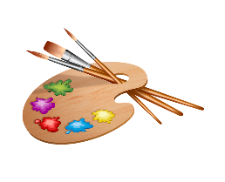 | In art, we will be studying pieces of graffiti art, focusing on the various techniques of different artists. By the end of the topic,
History  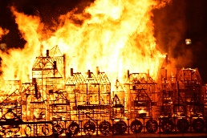 | We are extremely excited about our History topic this term as we will be studying Vikings and Anglo-Saxons. During this topic, we will be learning about life as a Viking. This will involve an overnight trip to the Jorvik Viking Centre.

