Banana and three seed energy bars
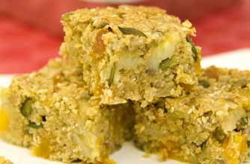

Makes: 9. Prep: 10 Min. Cooking: 30 Min

Give yourself and your kids an instant energy boost the healthy way, with this fabulous banana and seed snack

Ingredients
- 100g unsalted butter
- 3 level tbsp golden syrup
- 2 bananas, about 250g in total
- 150g porridge oats
- 100g ready-to-eat dried apricots, roughly chopped
- 25g pumpkin seeds
- 25g sunflower seeds
- 25g sesame seeds

Method
- Preheat the oven to 180°C (Gas Mark 4). Lightly grease a 20 x 20cm baking tin and line the bottom with non-stick baking parchment.
- Warm the butter and syrup in a heavy-based saucepan over a medium heat for 5 minutes or until melted. Peel the bananas and cut into 1cm cubes. Remove the butter mixture from the heat and add the bananas and all the remaining ingredients. Mix thoroughly.
- Spoon the mixture into the prepared tin and level the surface. Bake in the oven for 20-30 minutes or until golden. The mixture will still be quite soft in the centre. Remove from the oven and leave to cool completely.
- When cold, use a sharp knife to cut into 9 equal squares. Transfer to an airtight container. Don’t try to remove the bars from the tin while they are still warm because they will break.

Top tip for making Banana and three seed energy bars
These energy bars are a great way to use up overripe bananas - and contain considerably less sugar than most commercial cereal bars. They'll provide an instant energy boost but without sending your blood sugar levels soaring sky high.
Taken from www.goodtoknow.co.uk/recipes

