Raisin and banana cookies recipe
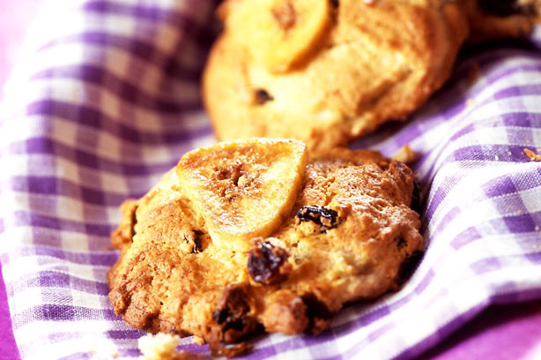

Serves: 16

Nutrition per portion |  | RDA
Calories | 119 kCal | 6%
Fat | 5g | 7%
- Saturates | 2.9gg | 15%
- of which Sugars | 10gg | 11%
Salt | 0.2gg | 3%
These cookies make an ideal snack or lunchbox addition and are a favourite with children and adults alike. It’s a tasty way to sneak in one of your five-a-day.

Ingredients
- 85g/3oz unsalted butter, softened slightly
- 80g/3oz light brown soft sugar
- A few drops of vanilla extract
- 1 large egg, beaten
- 1 small ripe banana, peeled and mashed
- 175g/7oz self raising flour, sifted
- 85g/3oz raisins
- 16 banana chips to decorate

Method
- To make this cookie recipe, preheat the oven to 180°C (350°F, gas mark 4).
- Combine the butter, sugars and vanilla in a large bowl and beat together with a wooden spoon until light and fluffy. Add the beaten egg and mashed banana and mix together. Then stir in the flour and raisins until well mixed and all the flour is incorporated.
- Using a spoon, divide the mixture into 16 equal amounts and place on lightly greased baking trays, leaving space in between each to allow for spreading during cooking. Top each cookie with a banana chip then bake in the preheated oven for 8-10 mins or until golden brown.
- Remove from the oven and leave to cool for 2-3 mins before removing from the baking trays and transferring to a cooling rack to cool completely.

Top tip for making Raisin and banana cookies
These will store for 1-2 days in an airtight container.
Taken from www.goodtoknow.co.uk/recipes

